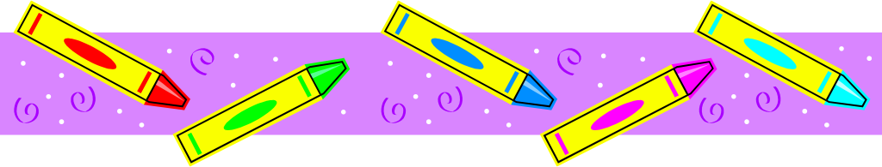
Supply List – September 2023-2024
Mrs. Hoxhaj
Grade 1
3 composition notebooks (there must be a margin with lines to write on from top to bottom)
4 packages #2 Ticonderoga pencils
2 black felt tip pens or fine tip Sharpie pens
1 small box Crayola crayons
1 package Crayola washable markers
1 package Crayola colored pencils
1 pair child sized Fiskar scissors
2 packages Elmer’s glue sticks (4 or more glue sticks package)
2 sharpeners with receptacle
2 packages eraser tops
1 roll Scotch tape
2 GREEN two pocket poly folders with bottom pockets
1 package EXPO markers
5 boxes of Kleenex tissues
4 Clorox tubs of disinfecting wipes
1 LARGE plastic pencil box for supplies (place your child’s name on this box)
1 backpack with NO wheels
1 package white printer paper
1 clipboard
1 pair headphones for laptop use (these stay in school and please label with name)
1 refillable PLASTIC water bottle

Grade 2
Please purchase ALL of the above and add/change:
2 BLUE two pocket poly folders with bottom pockets (instead of green)
1 large homework pad (lined- this can be a composition notebook, too)
Second graders do not need to purchase a clipboard.

Grade 3
Please purchase ALL items in first grade section and add/change:
2 RED two pocket poly folders with bottom pockets (instead of green)
1 large homework pad (lined-this can be a composition notebook, too)
Third graders do not need to purchase a clipboard.

●Keep your store receipts! Please label all items with your child’s first and last name. Some items will be placed in a community basket for all students to share.

**ALL STUDENTS: Please have your child create a collage on one composition notebook (back and front) using family photos, pictures from magazines, favorite foods, places, words and pictures from vacation brochures, etc. Please use a glue stick. This will be your child’s writer’s journal. Due 9/7/2023!

- Summer reading and work will be collected the first week of school.

•If your child has any food allergies, or takes medication that we need to know about, please send an updated note/prescription from your doctor to explain.

● Please provide extra snacks and an extra drink each day for snack time. The teacher will not provide snacks.
•Please purchase a set of supplies to keep at home; for homework and project purposes. (Pencils, construction paper, a sharpener, crayons, glue, scissors, and a ruler).

